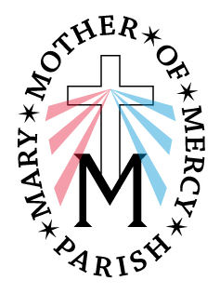
Mary, Mother of Mercy Parish
Our Lady Queen of Peace Church
Extraordinary Minister of Holy Communion
Guidelines

- Please remember to go into the sacristy and sign in the book. The only time you do not have to sign is when you are replacing a minister at the last minute.
- All ministers (Eucharistic and Lector) line up in back of church before Mass for the procession.
- As you process towards the altar, step to either side in front of the first pew. When the priest bows at the altar, bow with him and then go to your pew.
- All Ministers sit in the front of the church on the right side.
- Come forward during the “Sign of Peace”
- Enter the Sacristy by way of the side hall door and wash your hands.
- Stand ready at the doorway that leads to the Sanctuary until the priest
has received the Chalice with the Blood of Christ.
- Enter the Sanctuary and approach the side of the Altar. the priest or [deacon]
will offer you Holy Communion – the consecrated Body of Christ – and then give you a ciborium.
- When the priest [and deacon] heads to his station for distribution of Holy Communion please accompany him as usual. Stand in front of the first pews facing the altar to distribute communion.
- After Communion, in keeping with appropriate norms, the priest [or deacon] will
Place the remaining consecrated host in the tabernacle. you should then purify your hands by the Tabernacle or in the Sacristy, and return to your pew thru the Sacristy.

Thank you for your service to our parish and our people.

